Lab 04 – Arhaan Girdhar 220962050

Q1. Write a web page which contains table with 3 X 3 dimensions (fill some data) and one image. Style the rows with alternate color. Move the table and image together from right to left when button is clicked.

<!DOCTYPE html>
<html lang="en">
<head>
<meta charset="UTF-8">
<meta name="viewport" content="width=device-width, initial-scale=1.0">
<title>Table | Image</title>
<script src="https://code.jquery.com/jquery-3.6.0.min.js"></script>
<style>
body {
font-family: Arial, sans-serif;
}
table {
width: 300px;
border: 1px solid #000;
border-collapse: collapse;
margin-bottom: 20px;
}
th, td {
padding: 10px;
text-align: center;
}
tr:nth-child(even) {
background-color: #f2f2f2;
}
img {
width: 100px;
height: auto;
margin-top: 20px;
}
#container {
position: relative;
width: 100%;
overflow: hidden;
}
#moveableContent {
display: flex;
justify-content: flex-start;
position: relative; /* Add this line */
}
</style>
</head>
<body>

<h2>Move it Move it</h2>

<div id="container">
<div id="moveableContent">
<table>
<thead>
<tr>
<th>A</th>
<th>B</th>
<th>C</th>
</tr>
</thead>
<tbody>
<tr>
<td>1</td>
<td>2</td>
<td>3</td>
</tr>
<tr>
<td>4</td>
<td>5</td>
<td>6</td>
</tr>
<tr>
<td>7</td>
<td>8</td>
<td>9</td>
</tr>
</tbody>
</table>

<img src="placeholder.jpg"Placeholder Image">
</div>
</div>

<button id="moveButton">Move Right to Left</button>

<script>
$(document).ready(function() {
$('#moveButton').click(function() {
$('#moveableContent').animate({
left: "-100%"
}, 2000, function() {
// Reset position to right after animation completes
$('#moveableContent').css('left', '100%');
});
});
});
</script>

</body>
</html>

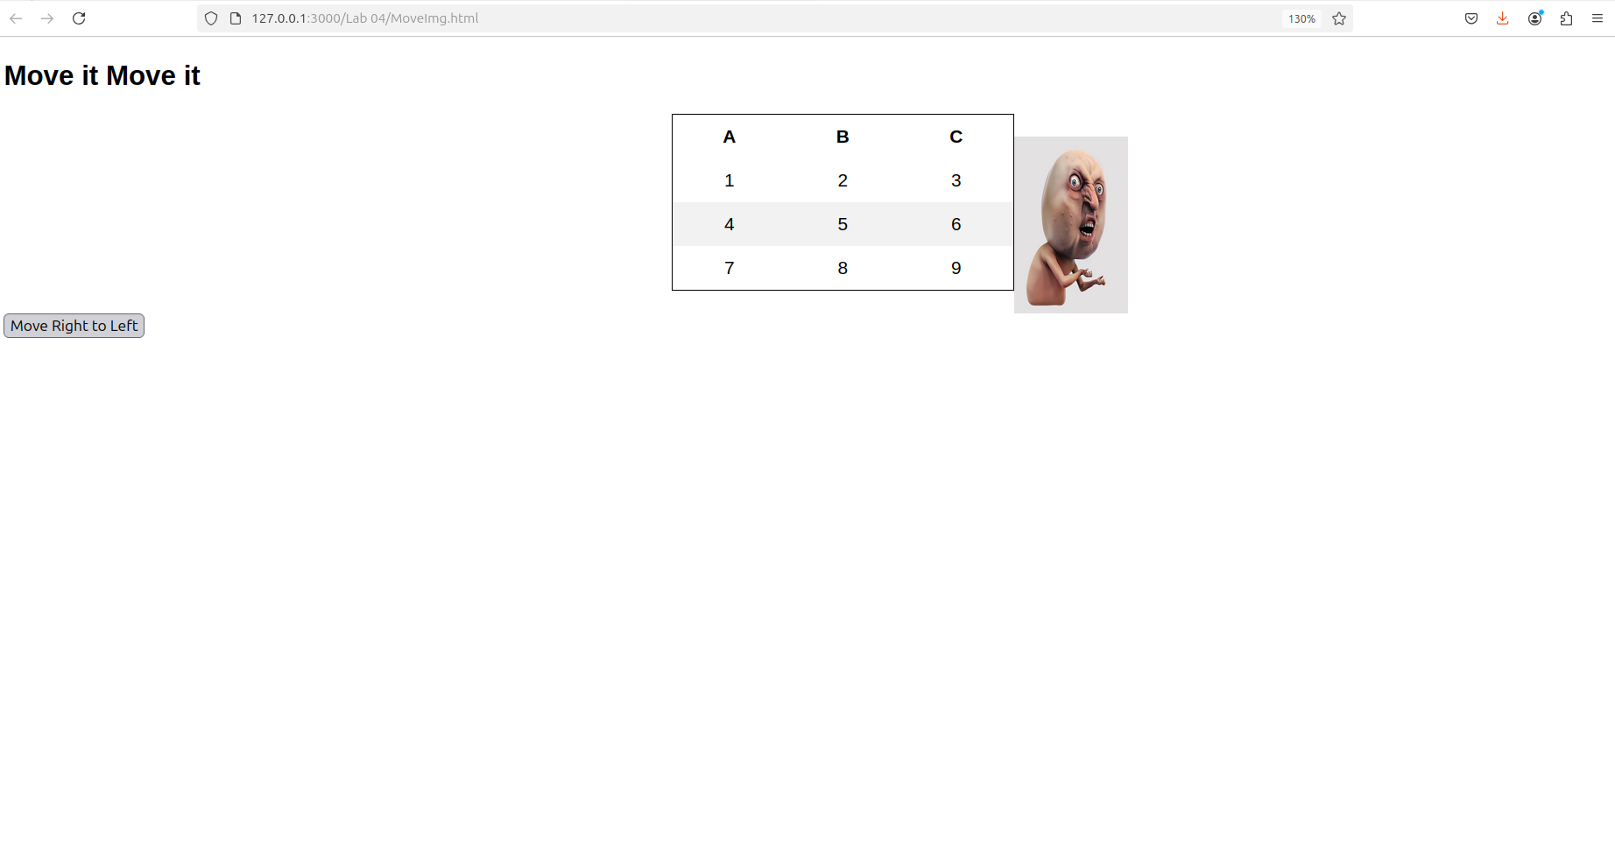

Q2. Design a calculator to perform basic arithmetic operations. Use textboxes and buttons
to design web page.

<!DOCTYPE html>
<html lang="en">
<head>
<meta charset="UTF-8">
<meta name="viewport" content="width=device-width, initial-scale=1.0">
<title>Simple Calculator</title>
<script src="https://code.jquery.com/jquery-3.6.0.min.js"></script>
<style>
body {
font-family: Arial, sans-serif;
display: flex;
justify-content: center;
align-items: center;
height: 100vh;
background-color: #1a1a1a;
margin: 0;
}

.calculator {
background-color: #333;
padding: 12px;
border-radius: 10px;
box-shadow: 0 4px 8px rgba(0, 0, 0, 0.1);
width: 300px;
color: #fff;
}

.calculator input {
width: 100%;
padding: 15px;
margin-bottom: 20px;
font-size: 20px;
text-align: right;
border: 2px solid #ccc;
border-radius: 5px;
background-color: #222;
color: #fff;
}

.calculator button {
width: 48%;
padding: 15px;
margin: 5px 1%;
font-size: 20px;
border: none;
border-radius: 5px;
background-color: #444;
color: #fff;
cursor: pointer;
}

.calculator button:active {
background-color: #555;
}

.calculator button.operator {
background-color: #ff9800;
}

.calculator button.operator:active {
background-color: #f57c00;
}

.calculator button.clear {
background-color: #f44336;
}

.calculator button.clear:active {
background-color: #e53935;
}

.calculator button.equal {
background-color: #4CAF50;
}

.calculator button.equal:active {
background-color: #45a049;
}

.calculator .row {
display: flex;
justify-content: space-between;
margin-bottom: 02px;
}

</style>
</head>
<body>

<div class="calculator">
<input type="text" id="display" disabled>

<div class="row">
<button onclick="appendNumber(7)">7</button>
<button onclick="appendNumber(8)">8</button>
<button onclick="appendNumber(9)">9</button>
<button onclick="setOperator('+')" class="operator">+</button>
</div>

<div class="row">
<button onclick="appendNumber(4)">4</button>
<button onclick="appendNumber(5)">5</button>
<button onclick="appendNumber(6)">6</button>
<button onclick="setOperator('-')" class="operator">-</button>
</div>

<div class="row">
<button onclick="appendNumber(1)">1</button>
<button onclick="appendNumber(2)">2</button>
<button onclick="appendNumber(3)">3</button>
<button onclick="setOperator('*')" class="operator">*</button>
</div>

<div class="row">
<button onclick="appendNumber(0)">0</button>
<button onclick="clearDisplay()" class="clear">C</button>
<button onclick="calculateResult()" class="equal">=</button>
<button onclick="setOperator('/')" class="operator">/</button>
</div>
</div>

<script>
let currentInput = "";
let previousInput = "";
let operator = null;

function appendNumber(number) {
currentInput += number;
document.getElementById('display').value = currentInput;
}

function clearDisplay() {
currentInput = "";
previousInput = "";
operator = null;
document.getElementById('display').value = "";
}

function setOperator(op) {
if (currentInput === "") return;
if (previousInput !== "") {
calculateResult();
}
operator = op;
previousInput = currentInput;
currentInput = "";
document.getElementById('display').value = previousInput + " " + operator;
}

function calculateResult() {
let result;
const prev = parseFloat(previousInput);
const current = parseFloat(currentInput);

if (isNaN(prev) || isNaN(current)) return;

switch (operator) {
case "+":
result = prev + current;
break;
case "-":
result = prev - current;
break;
case "*":
result = prev * current;
break;
case "/":
if (current === 0) {
alert("Cannot divide by zero");
return;
}
result = prev / current;
break;
default:
return;
}

document.getElementById('display').value = result;
previousInput = result;
currentInput = "";
operator = null;
}
</script>

</body>
</html>
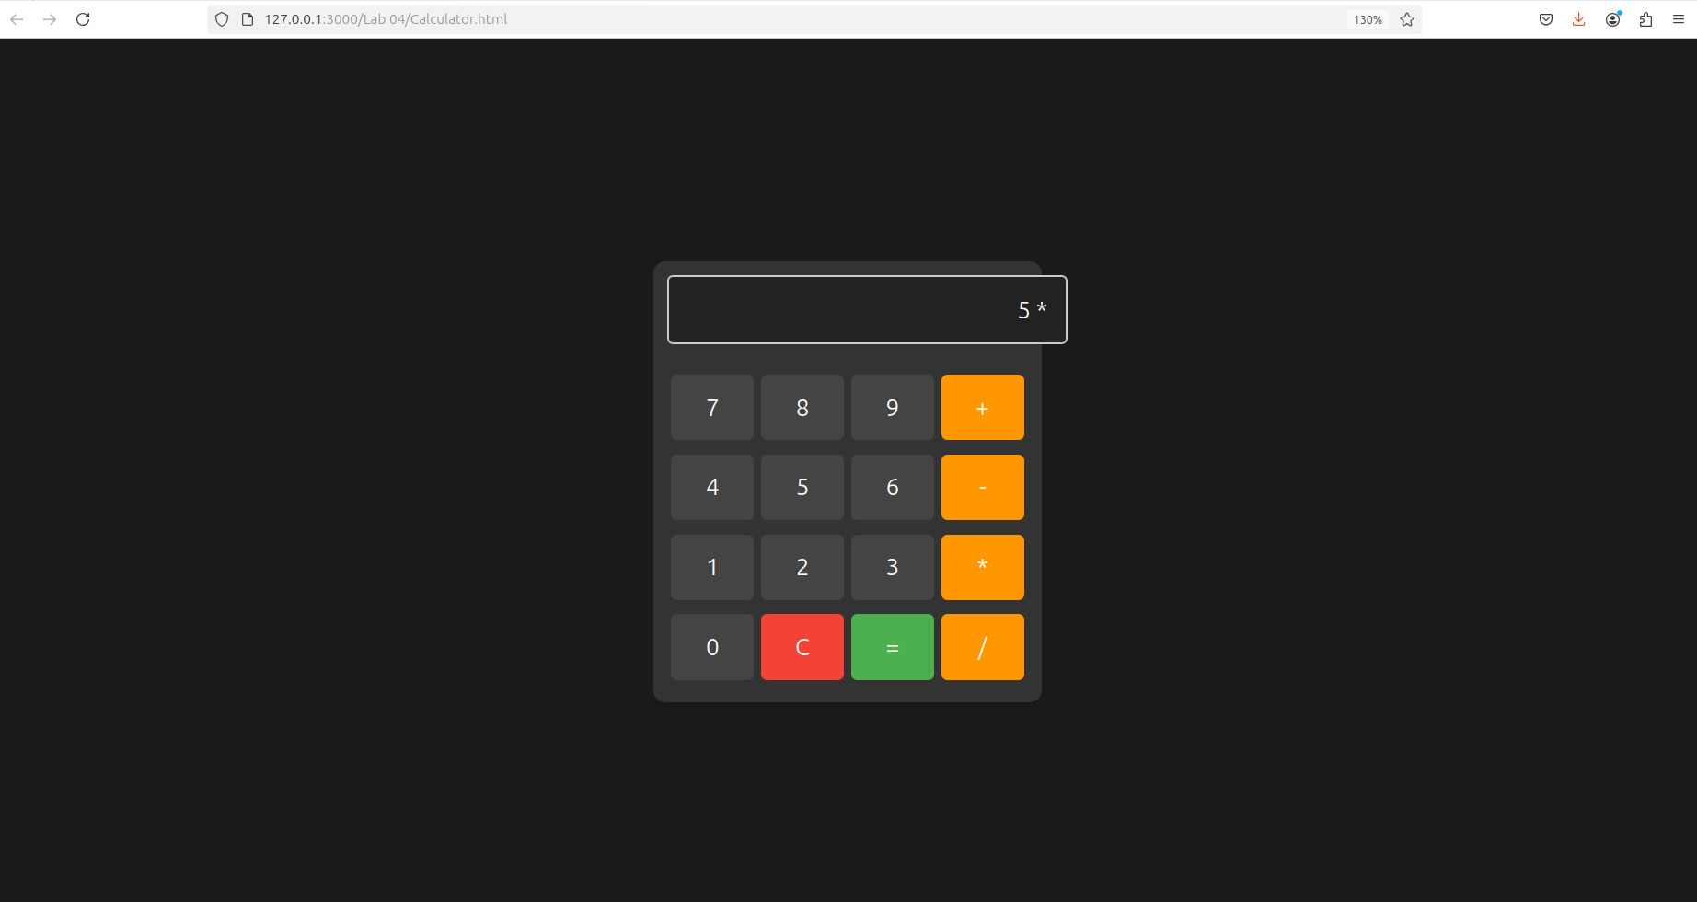

Q3. Create a web page to design a birthday card shown below.

<!DOCTYPE html>
<html lang="en">
<head>
<meta charset="UTF-8">
<meta name="viewport" content="width=device-width, initial-scale=1.0">
<title>Birthday Card Designer</title>
<script src="https://code.jquery.com/jquery-3.6.0.min.js"></script>
<style>
body {
font-family: Arial, sans-serif;
margin: 0;
padding: 0;
display: flex;
justify-content: center;
align-items: center;
height: 100vh;
background-color: #ecbd97;
}
.container {
display: flex;
width: 80%;
justify-content: space-between;
align-items: center;
}
.options {
width: 40%;
background-color: #ffffff;
padding: 20px;
border-radius: 10px;
box-shadow: 0px 4px 10px rgba(0, 0, 0, 0.1);
}
.options h3 {
margin-bottom: 15px;
}
.options label, .options input, .options select {
margin-bottom: 10px;
width: 100%;
padding: 8px;
box-sizing: border-box;
}
.card {
width: 350px;
height: 450px;
padding: 20px;
text-align: center;
border-radius: 10px;
background-color: #f9f9f9;
transition: all 0.5s ease;
box-shadow: 0px 4px 10px rgba(0, 0, 0, 0.1);
}
.image {
width: 150px;
margin-top: 20px;
border: 1px solid #000000;
border-radius: 10px;
}
textarea {
resize: none;
}
.toggle-button {
background-color: #964f7b;
color: white;
border: none;
padding: 10px;
cursor: pointer;
border-radius: 5px;
width: 100%;
}
</style>
</head>
<body>
<div class="container">
<div class="options">
<h3>Customize Card</h3>

<label>Choose a background color:</label>
<select id="bgColor">
<option value="yellow">Yellow</option>
<option value="lightblue">Light Blue</option>
<option value="lightpink">Light Pink</option>
<option value="lightgreen">Light Green</option>
<option value="lavender">Lavender</option>
</select><br><br>

<label>Choose a font:</label>
<select id="fontType">
<option value="Verdana">Verdana</option>
<option value="Arial">Arial</option>
<option value="Times New Roman">Times New Roman</option>
<option value="Courier New">Courier New</option>
<option value="Georgia">Georgia</option>
<option value="Comic Sans MS">Comic Sans MS</option>
</select><br><br>

<label>Specify font size:</label>
<input type="number" id="fontSize" value="25"><br><br>

<label>Choose a border style:</label><br>
<input type="radio" name="border" value="none" checked> None
<input type="radio" name="border" value="double"> Double
<input type="radio" name="border" value="solid"> Solid
<br><br>

<button id="toggleImage" class="toggle-button">Show Cake !!</button><br><br>

<label>Enter greeting text:</label><br>
<textarea id="greetingText" rows="2">Happy Birthday, and many more</textarea><br><br>

<button id="updateCard">Update</button>
</div>

<div class="card" id="birthdayCard" style="background-color: lightcoral; font-family: Verdana; font-size: 25px; border: none;">
<p id="message">Happy Birthday, and many more</p>
<img id="cakeImage" class="image" src="cake.jpeg" alt="Cake" style="display: none;">
</div>
</div>

<script>
$(document).ready(function(){
$("#updateCard").click(function(){
$("#birthdayCard").css("background-color", $("#bgColor").val());
$("#birthdayCard").css("font-family", $("#fontType").val());
$("#birthdayCard").css("font-size", $("#fontSize").val() + "px");
$("#message").text($("#greetingText").val());

let borderStyle = $("input[name='border']:checked").val();
$("#birthdayCard").css("border", borderStyle === "none" ? "none" : `4px ${borderStyle} black`);

$("#birthdayCard").animate({
opacity: 0.5
}, 200, function(){
$(this).animate({
opacity: 1
}, 200);
});
});

$("#toggleImage").click(function(){
$("#cakeImage").toggle();
});
});
</script>
</body>
</html>

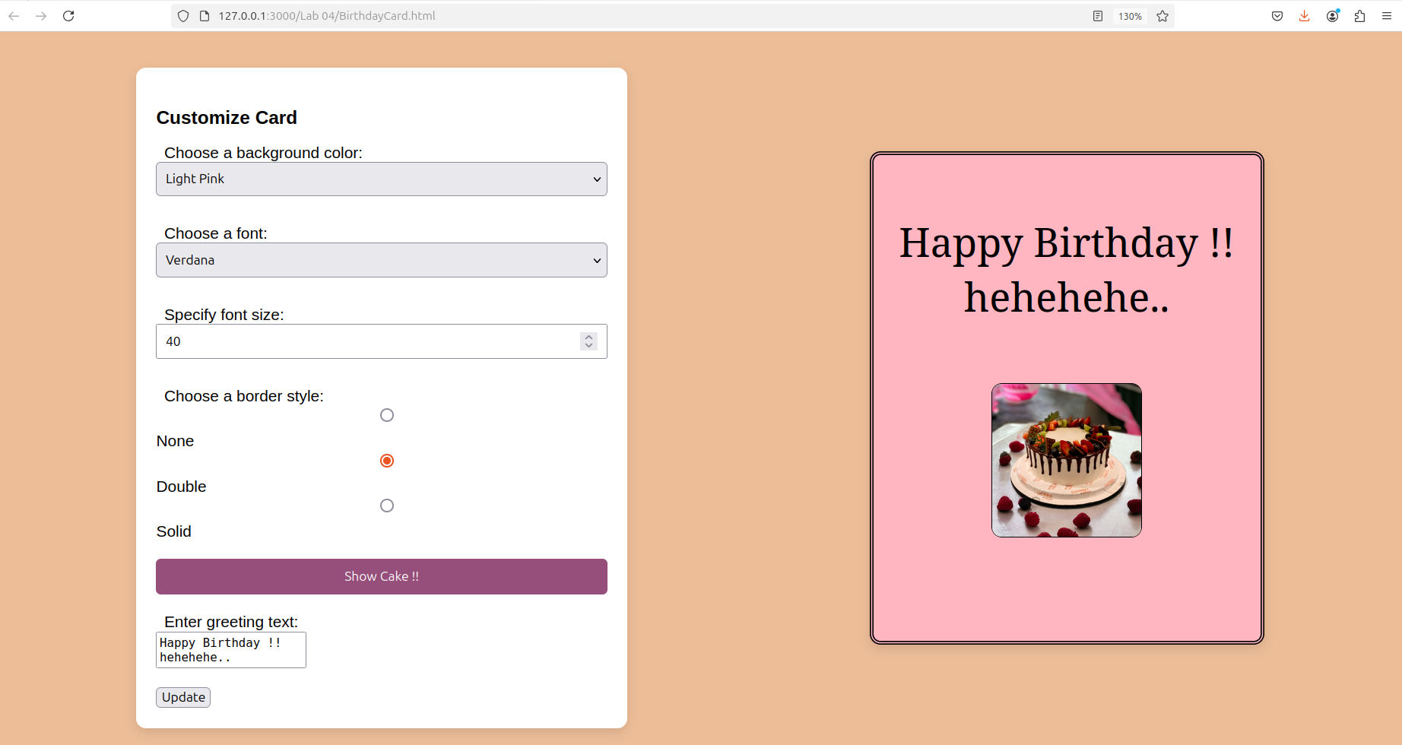

Q4. Design a webpage. The page contains:
• Dropdown list with HP, Nokia, Samsung, Motorola, Apple as items.
• Checkbox with Mobile and Laptop as items. Textbox where you enter quantity.
• There is a button with text as ‘Produce Bill’.
On Clicking Produce Bill button, alert should be displayed with total amount.

<!DOCTYPE html>
<html lang="en">
<head>
<meta charset="UTF-8">
<meta name="viewport" content="width=device-width, initial-scale=1.0">
<title>Product Bill</title>
<style>
body {
font-family: Arial, sans-serif;
padding: 20px;
}
.container {
max-width: 500px;
margin: 0 auto;
padding: 20px;
border: 1px solid #ccc;
border-radius: 8px;
background-color: #f9f9f9;
}
label {
display: block;
margin-bottom: 8px;
}
select, input[type="number"], button {
width: 100%;
padding: 8px;
margin-bottom: 10px;
border-radius: 4px;
border: 1px solid #ccc;
}
button {
background-color: #4CAF50;
color: white;
font-size: 16px;
cursor: pointer;
}
button:hover {
background-color: #45a049;
}
</style>
</head>
<body>

<div class="container">
<h2>Produce Bill</h2>

<label for="brand">Select Brand</label>
<select id="brand">
<option value="HP">HP</option>
<option value="Nokia">Nokia</option>
<option value="Samsung">Samsung</option>
<option value="Motorola">Motorola</option>
<option value="Apple">Apple</option>
</select>

<label>Product Type</label>
<input type="checkbox" id="mobile" name="productType" value="Mobile">
<label for="mobile">Mobile</label>
<input type="checkbox" id="laptop" name="productType" value="Laptop">
<label for="laptop">Laptop</label>

<label for="quantity">Enter Quantity</label>
<input type="number" id="quantity" name="quantity" min="1" required>

<button onclick="produceBill()">Produce Bill</button>
</div>

<script>
function produceBill() {
const brand = document.getElementById("brand").value;
const isMobileChecked = document.getElementById("mobile").checked;
const isLaptopChecked = document.getElementById("laptop").checked;
const quantity = document.getElementById("quantity").value;

let productType = "";
if (isMobileChecked) productType += "Mobile ";
if (isLaptopChecked) productType += "Laptop ";

if (!productType) {
alert("Please select at least one product type.");
return;
}

const priceList = {
"HP": 500,
"Nokia": 300,
"Samsung": 700,
"Motorola": 400,
"Apple": 1000
};

let price = priceList[brand];
if (!price) {
alert("Invalid brand selected.");
return;
}

const totalAmount = price * quantity;
alert(`Brand: ${brand}\nProduct Type: ${productType}\nQuantity: ${quantity}\nTotal Amount: $${totalAmount}`);
}
</script>

</body>
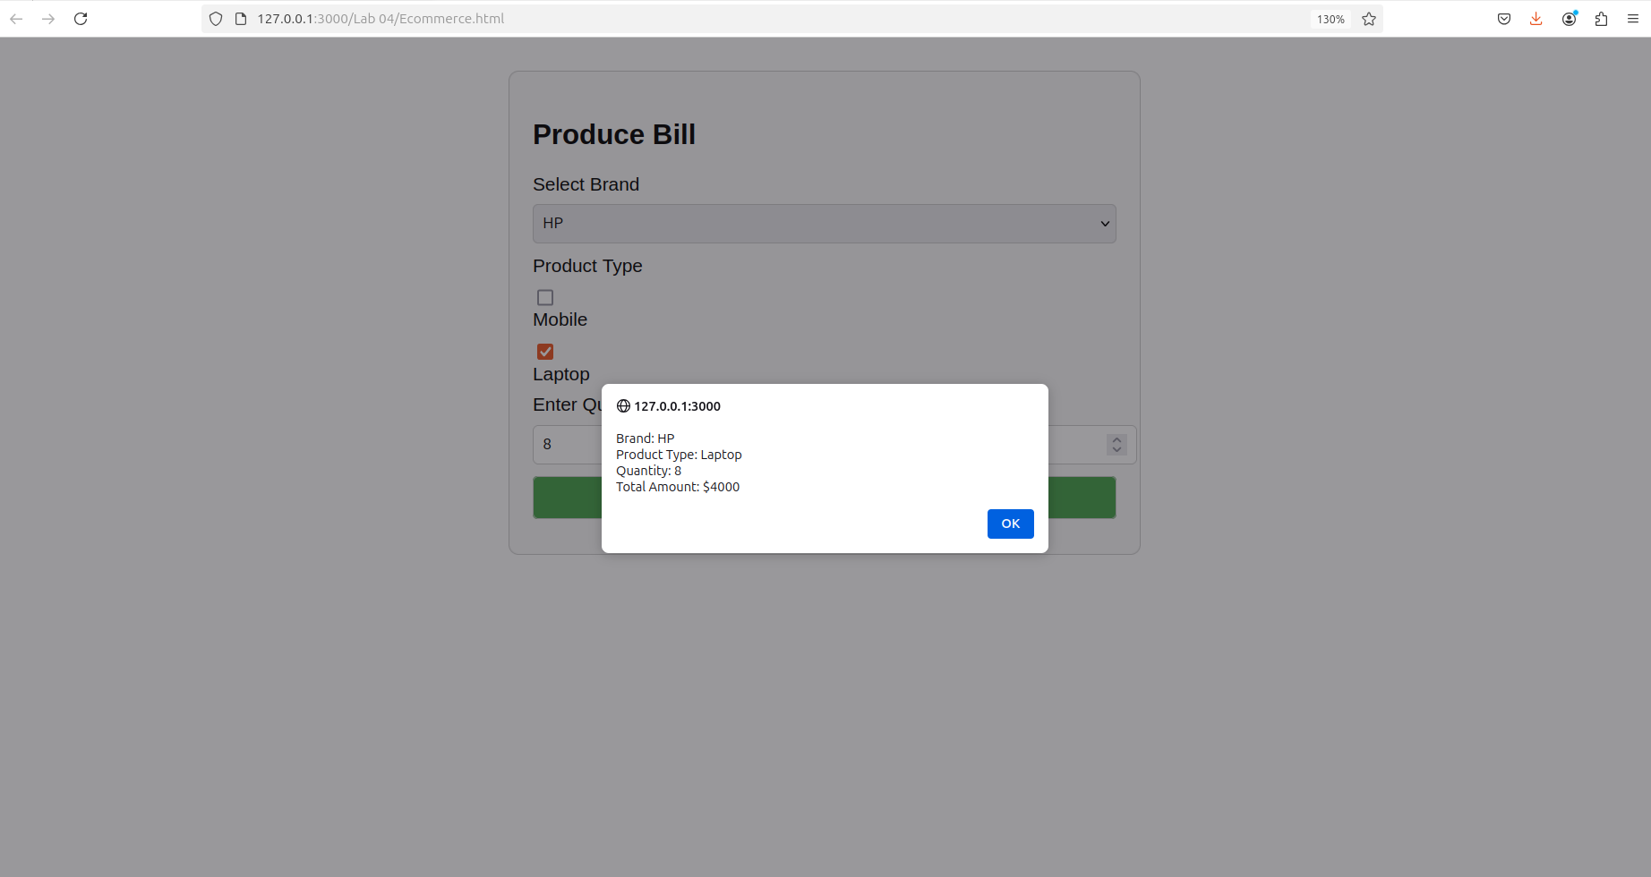
</html>

